Hindi Vidya Prachar Samiti’s
RAMNIRANJAN JHUNJHUNWALA COLLEGE OF ARTS , SCIENCE AND COMMERCE (EMPOWERED AUTONOMOUS)

Machine Learning System Design


Name: Surajkumar Yada
Roll no: 10404
Class : Msc. Data Science and Artificial Intelligence Part II


Ramniranjan Jhunjhunwala College of Arts, Science and Commerce

Department of Data Science and Artificial Intelligence

CERTIFICATE

This is to certify Sudhanshu Bisoi of Msc. Data Science and Artificial Intelligence Roll No-10401 has successfully completed the practical of Machine Learning System Design during the Academic Year 2025-2026.

Date :

(Prof. Shweta Gupta) External Examiner
Prof-In-Charge

INDEX

Sr. no. | Practical | Date | Sign
1 | Design a hotel booking chatbot. | 14/02/26
2 | Design a podcast search engine. | 14/02/26
3 | Design a personalized Uber. | 14/02/26
4 | Design type-ahead search for Stack Overflow | 27/02/26
5 | Design auto-complete for text messages. | 21/02/26
6 | Build a dynamic pricing system. | 21/02/26
7 | Predict user behaviour changes after product updates. | 27/02/26
8 | Design a framework for evaluating ad rankings. | 28/02/26
9 | Design a personalized newsfeed. | 27/02/26
10 | Design an image classifier. | 28/02/26

Practical 1 - Design a hotel booking chatbot
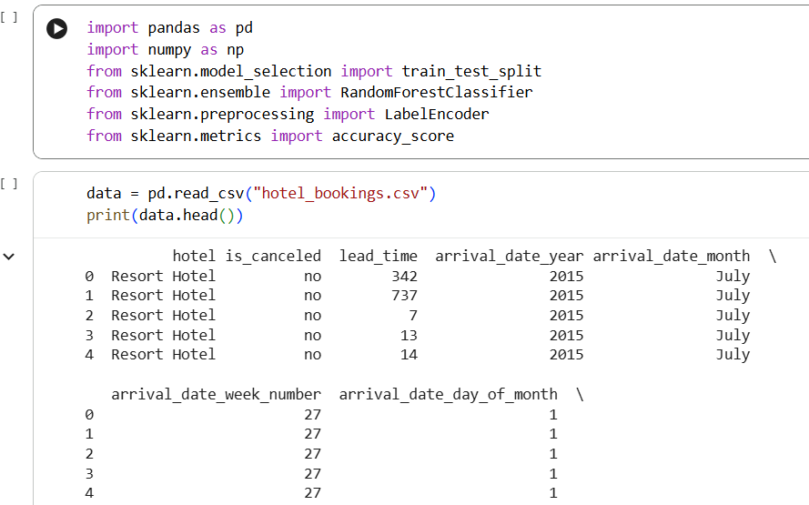
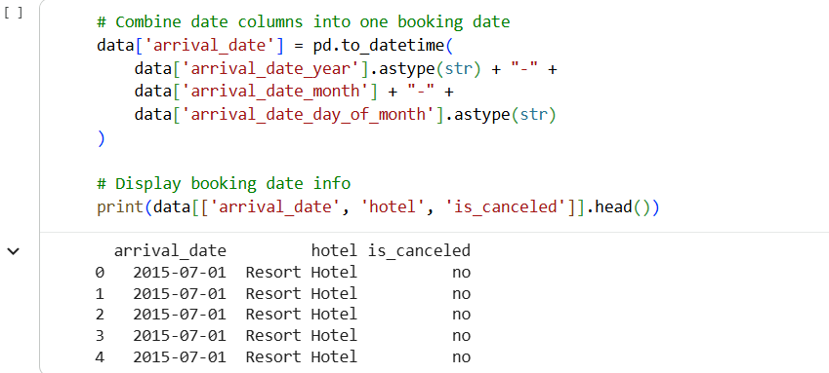

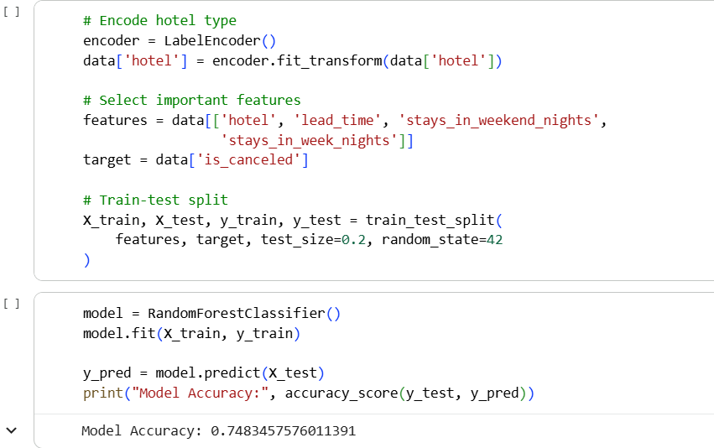

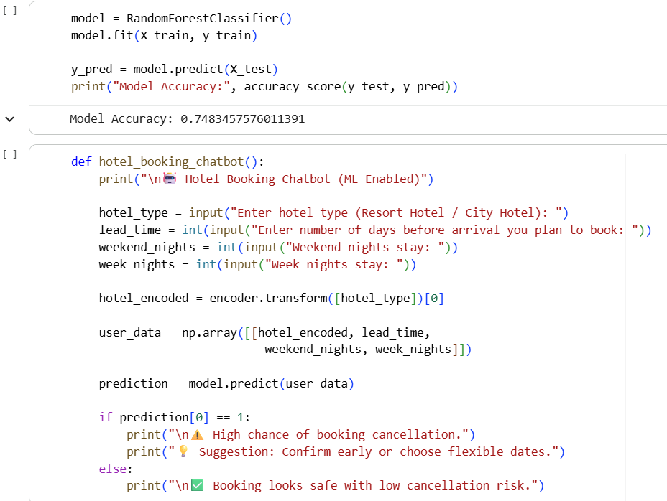
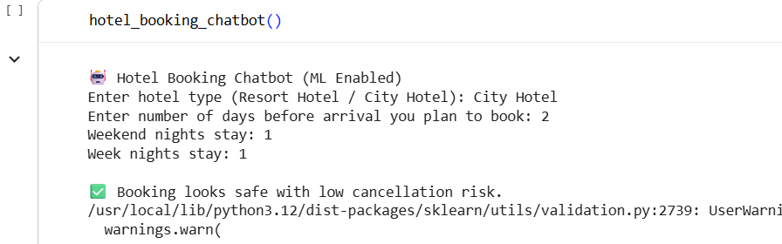

Practical 2 - Design a podcast search engine
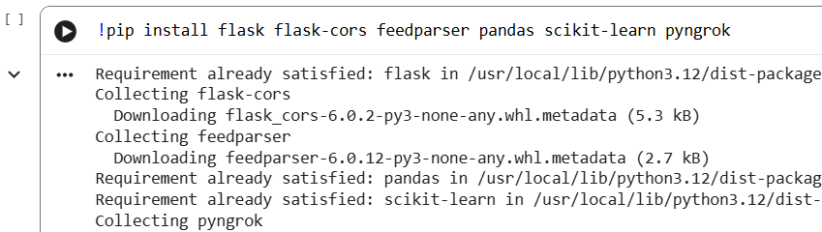
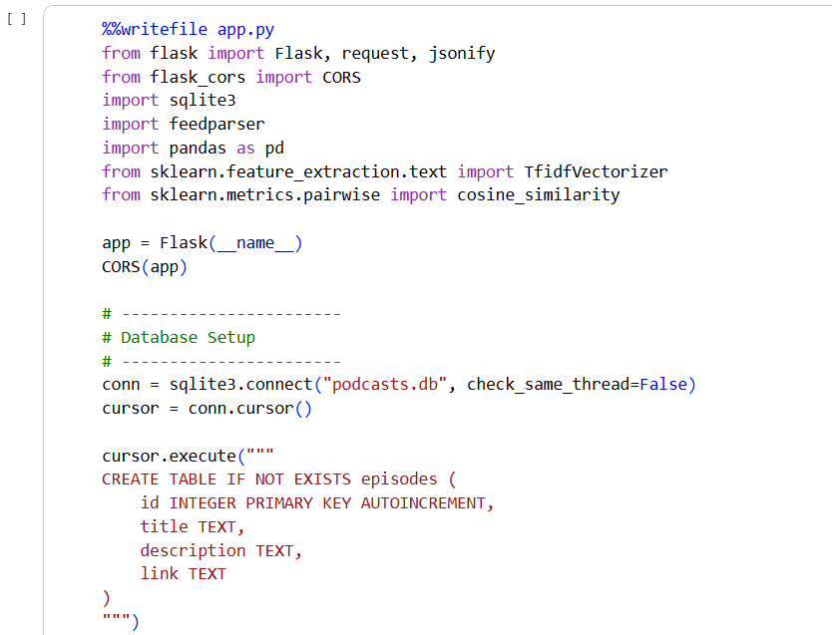
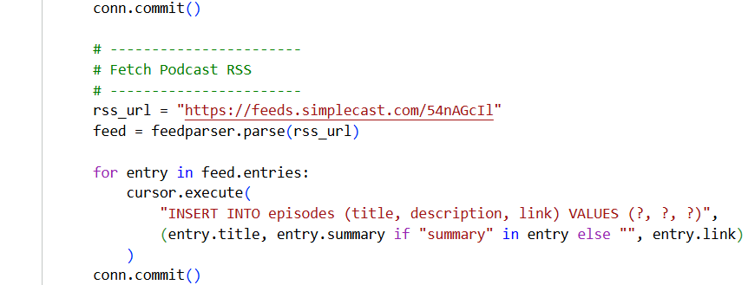

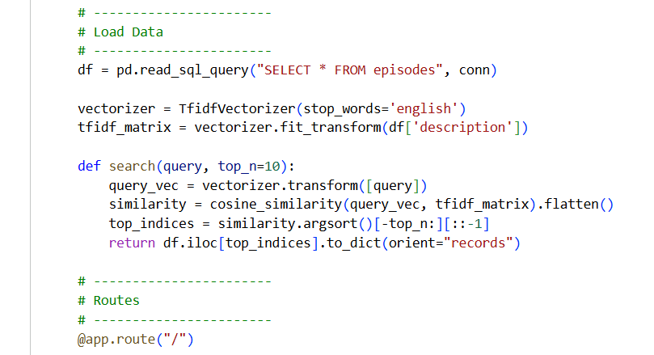
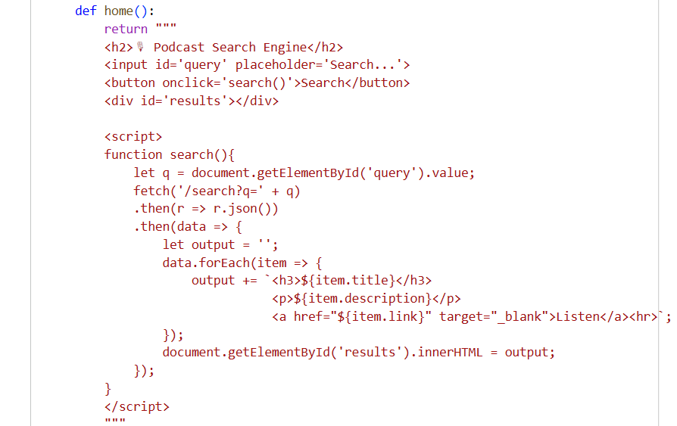
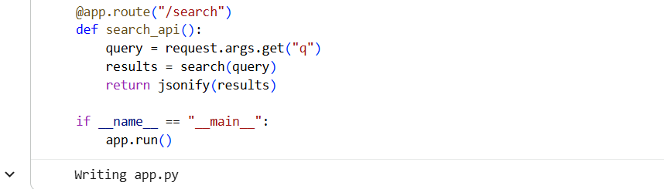

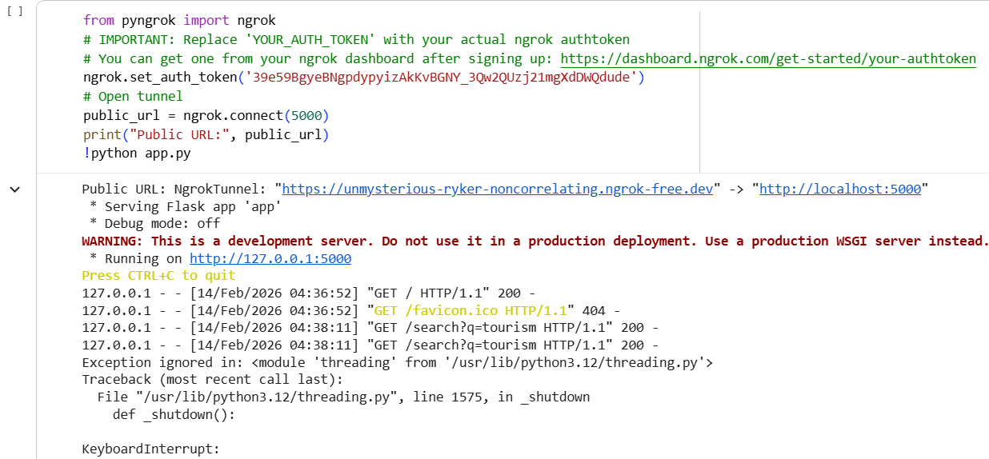
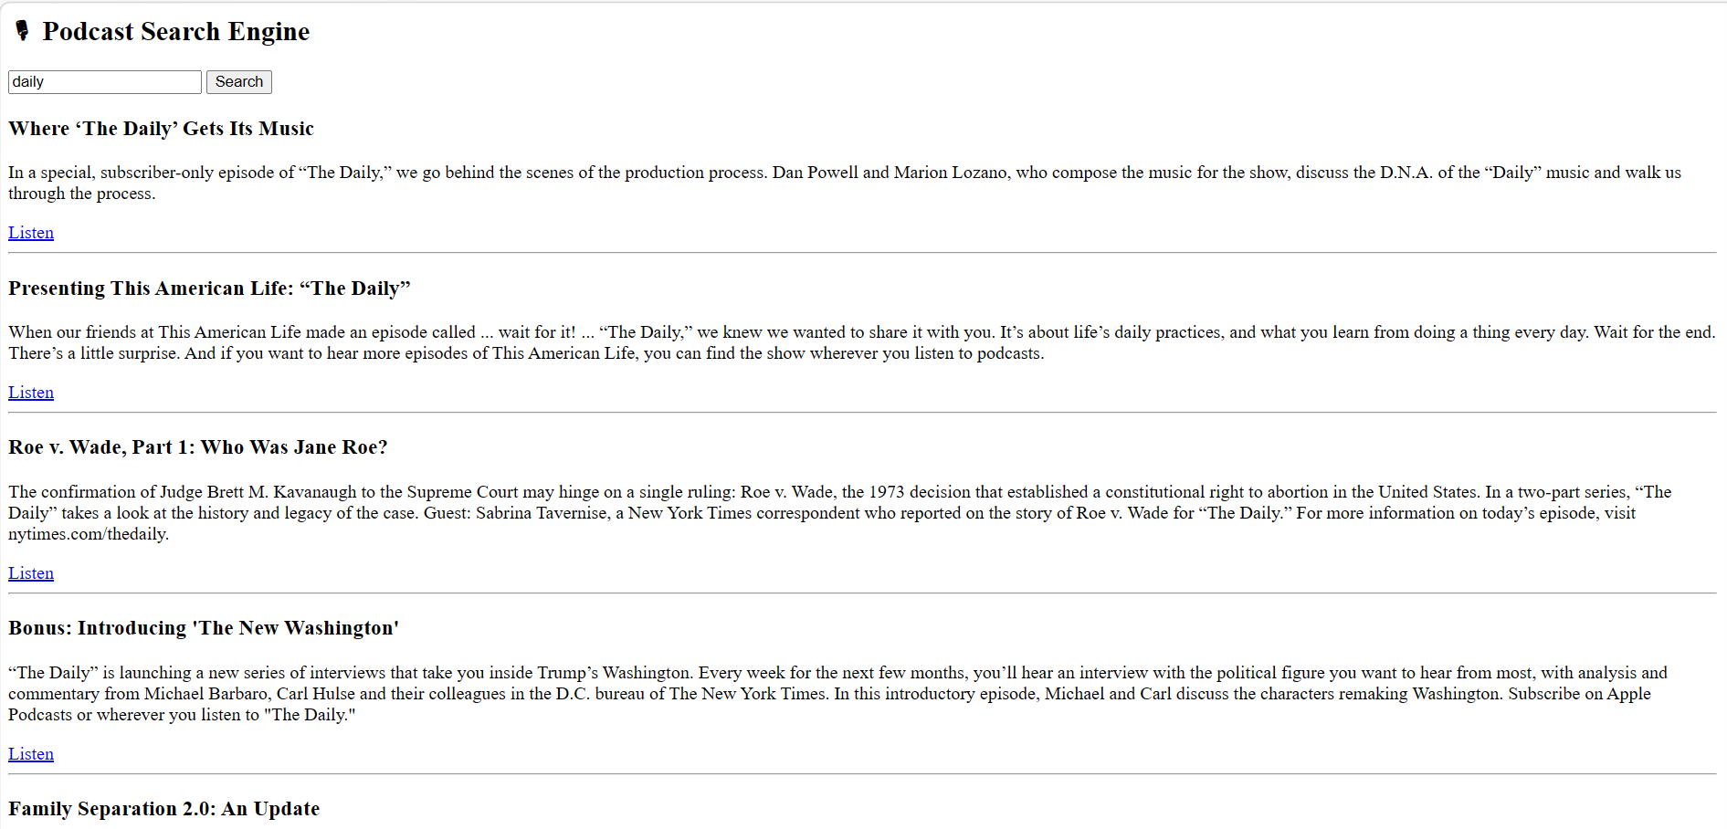

Practical 3 - Design a personalized Uber
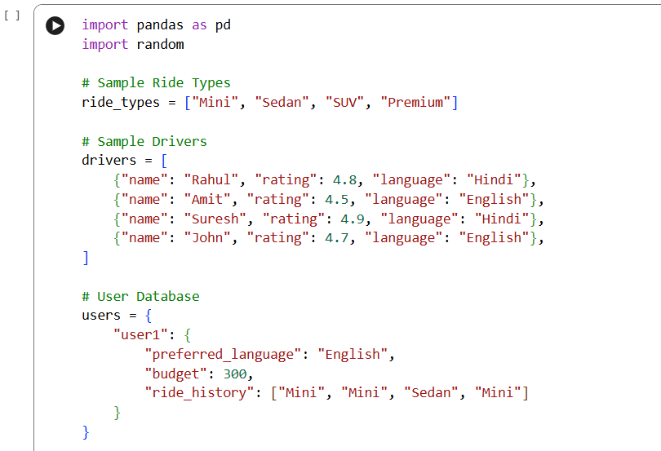
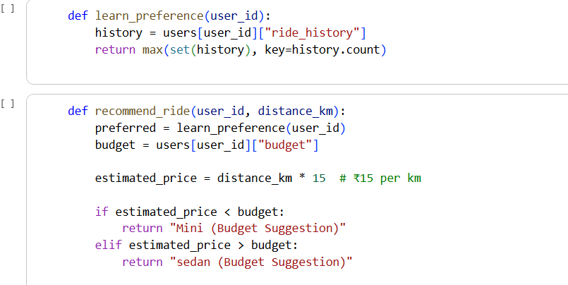
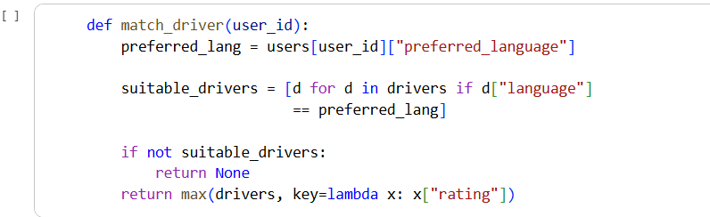

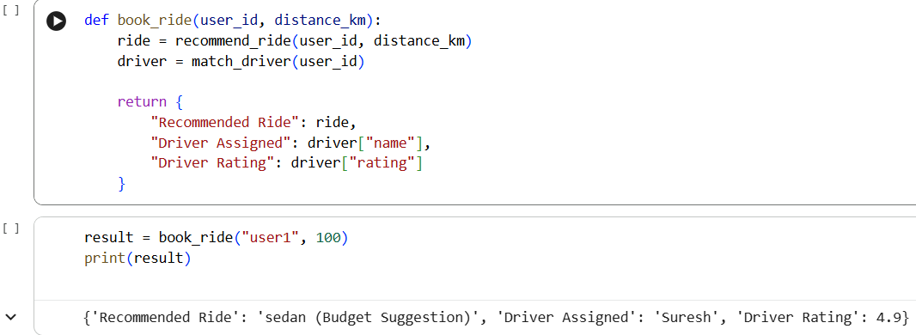

Practical 4 - Design type-ahead search for Stack Overflow
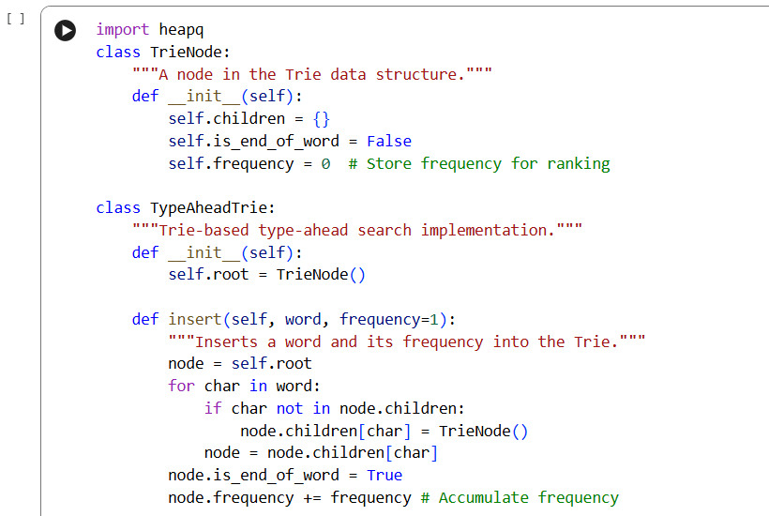
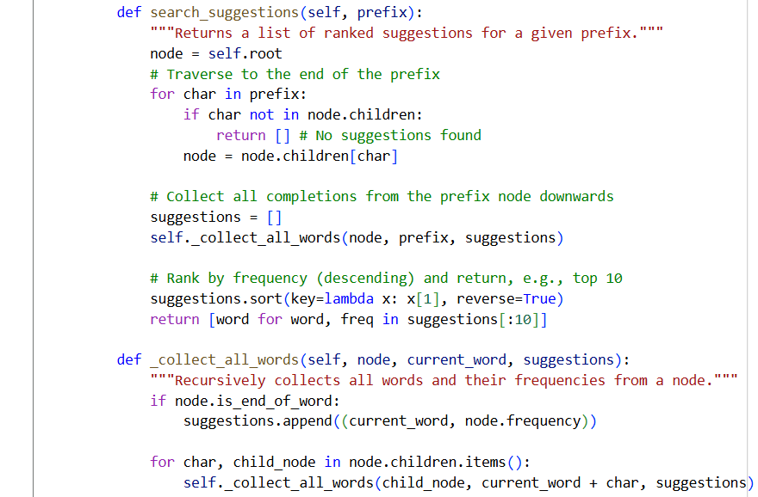
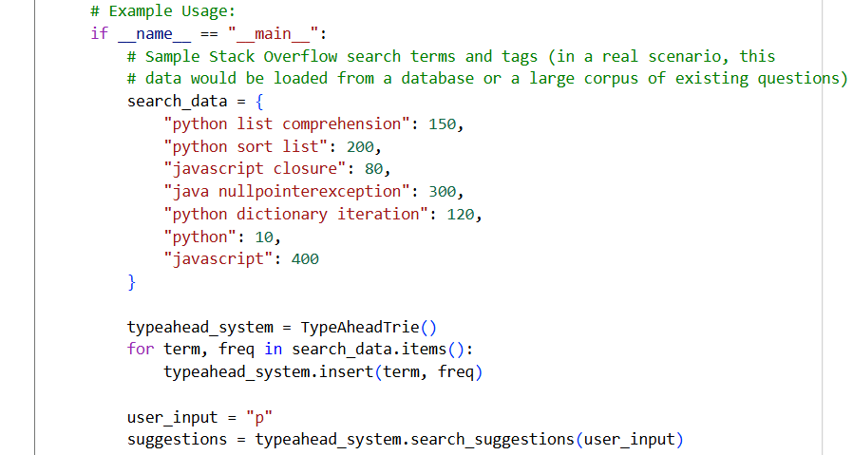
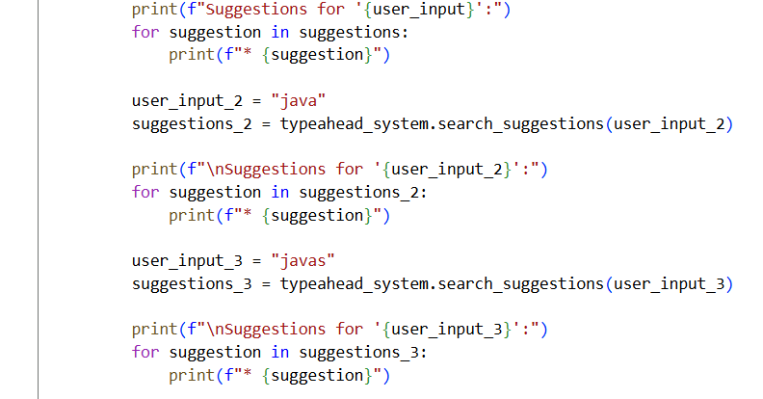
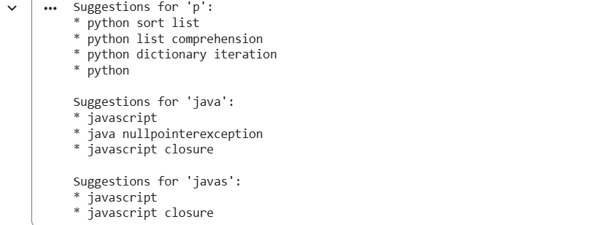

Practical 5 - Design autocomplete for text messages
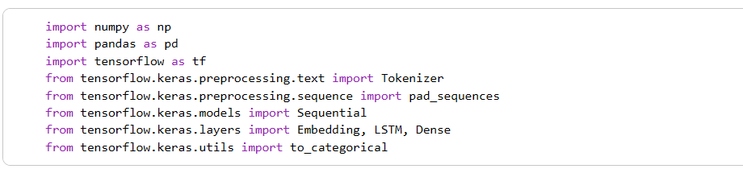
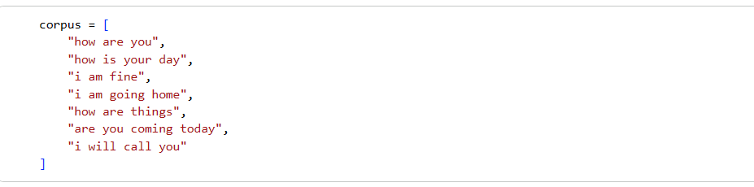
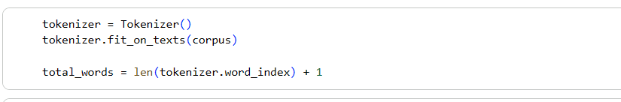
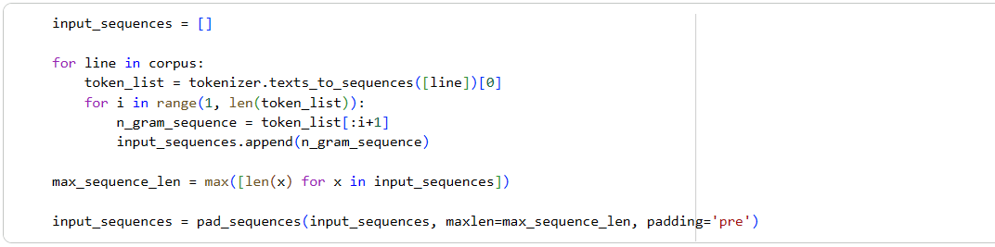
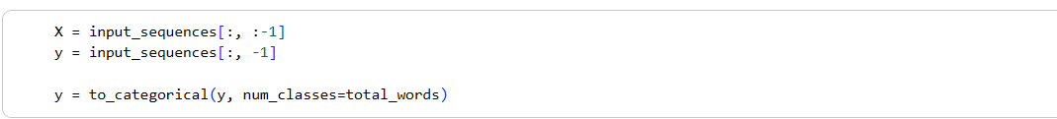
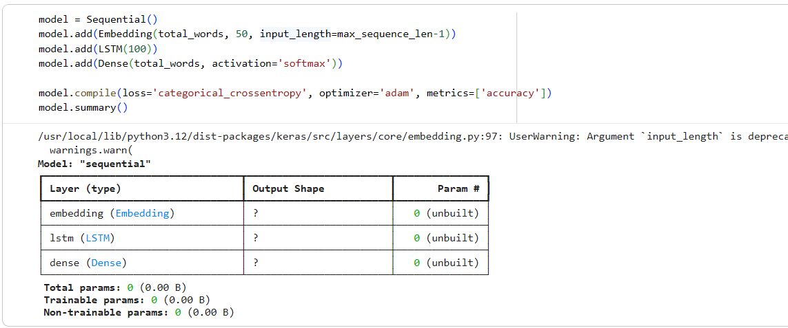
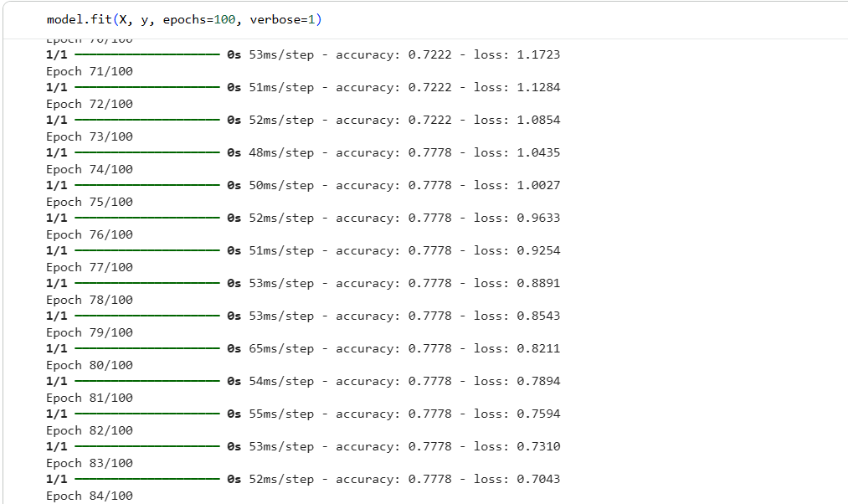
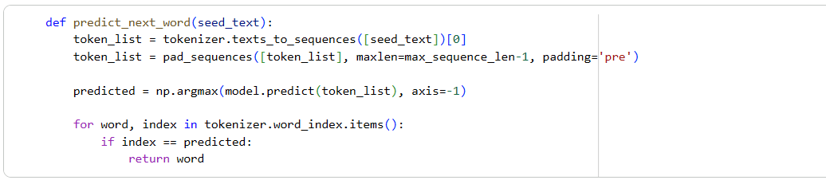
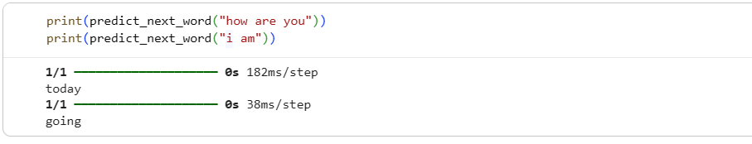
Using Tkinter :-
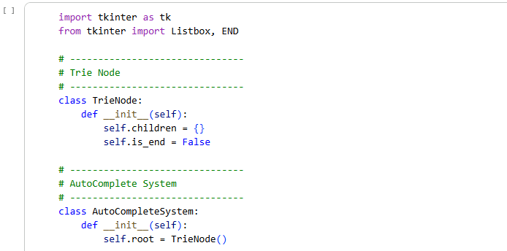
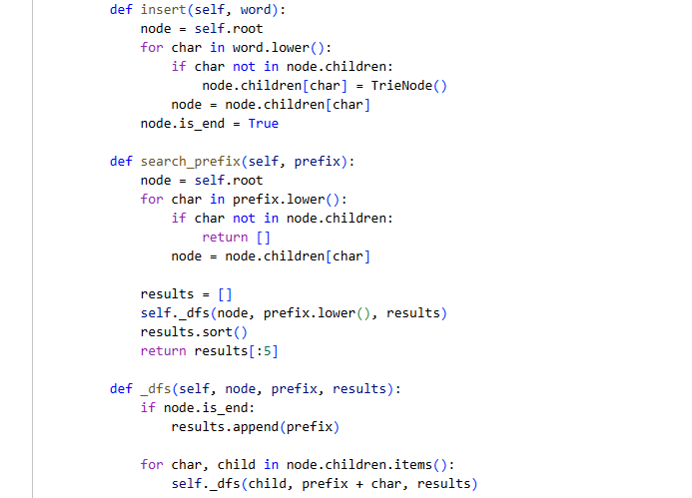
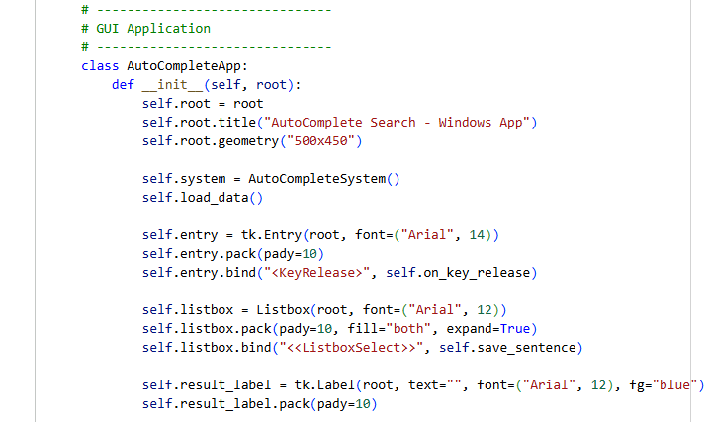
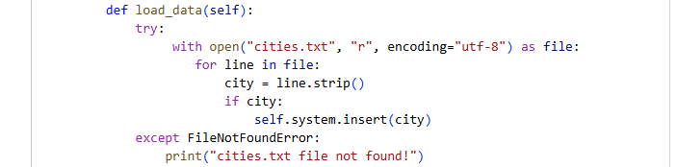

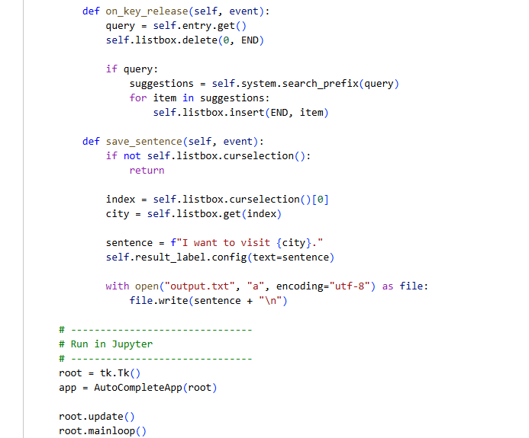
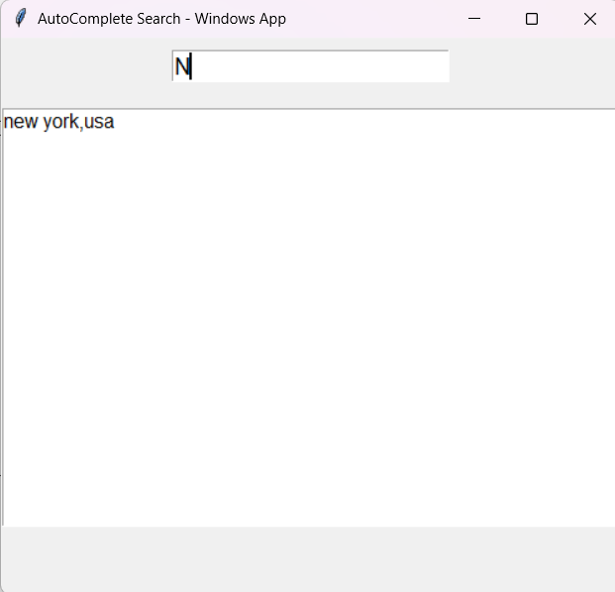

Practical 6 - Build a dynamic pricing system
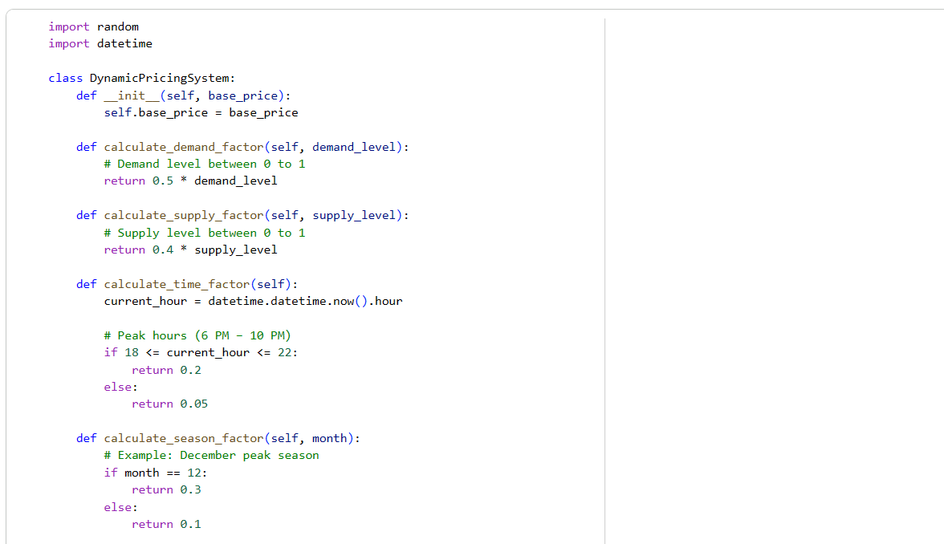
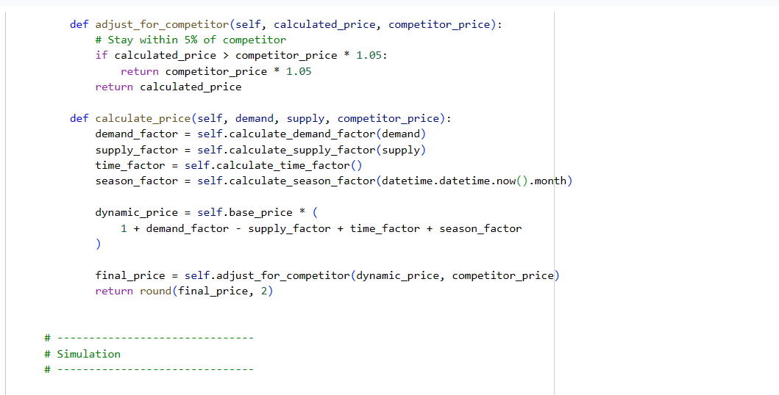
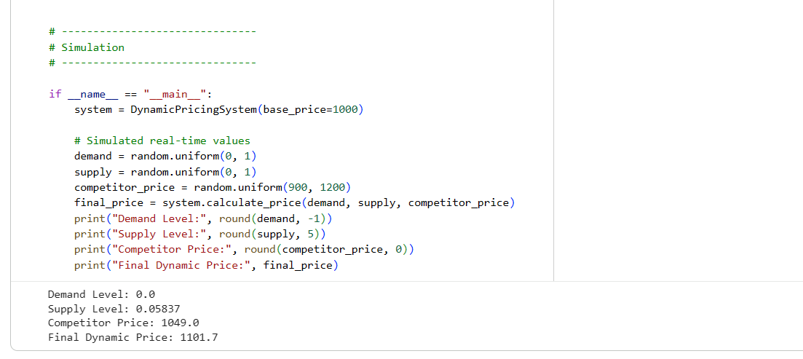
Practical 7 - Predict user behaviour changes after product updates
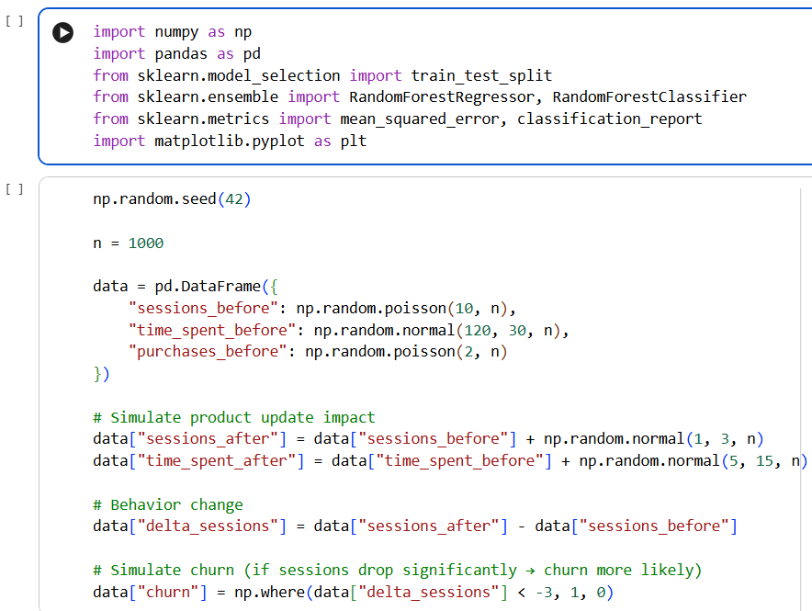
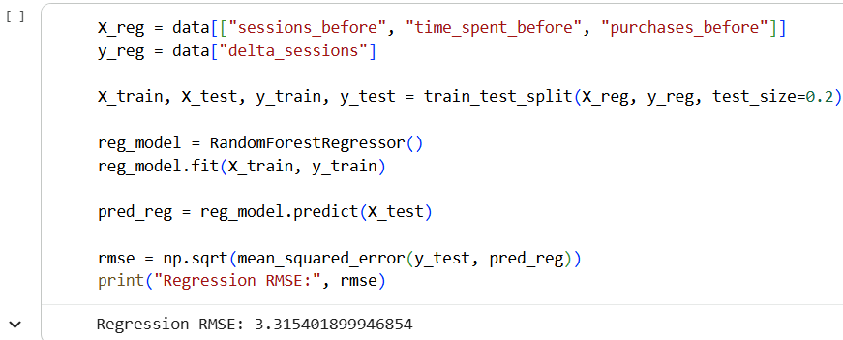
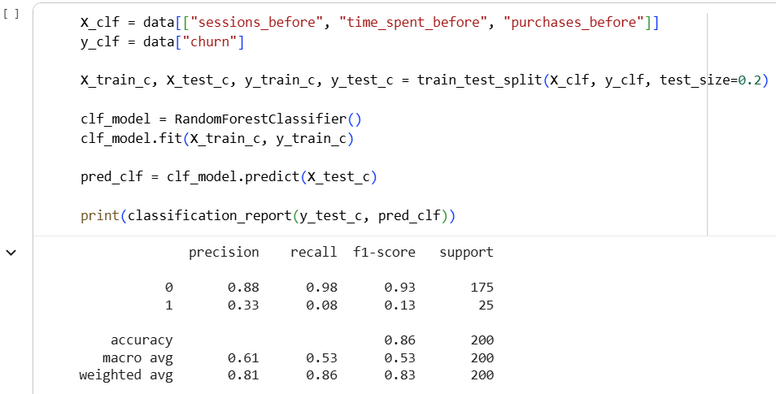
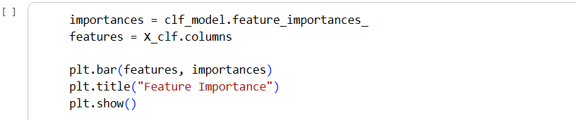
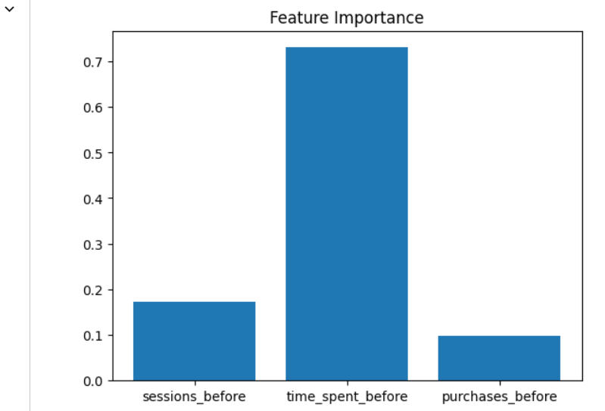

Practical 8 - Design a framework for evaluating ad rankings
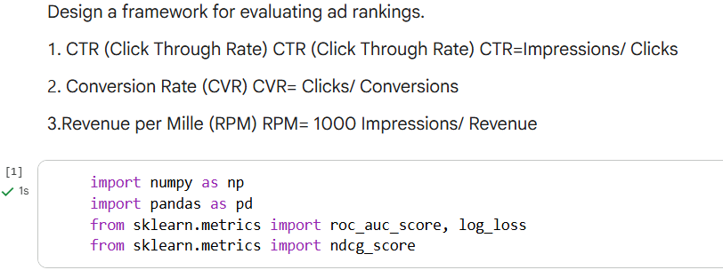
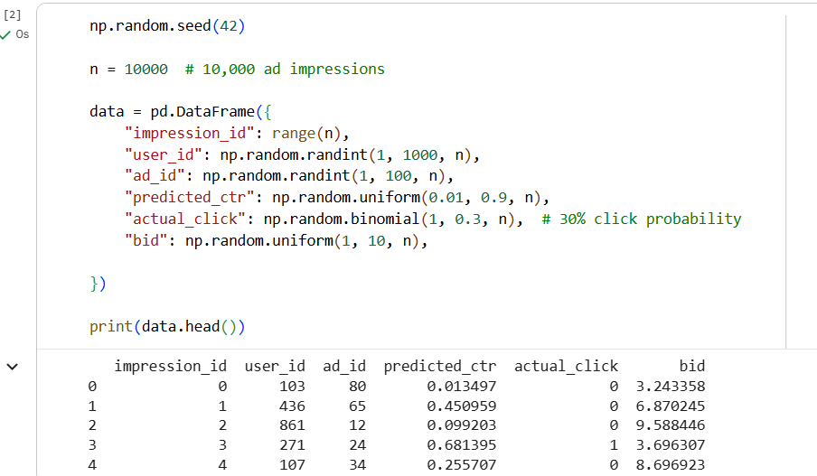
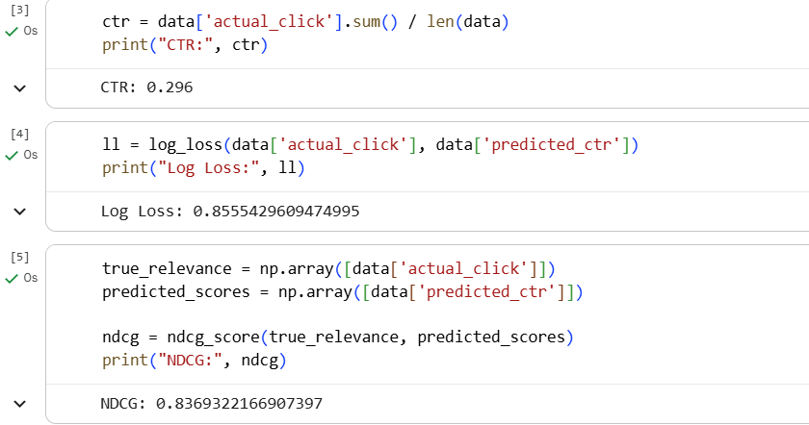

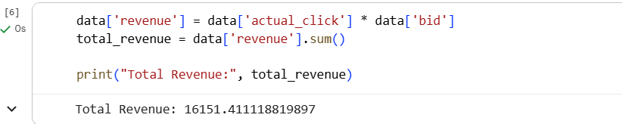
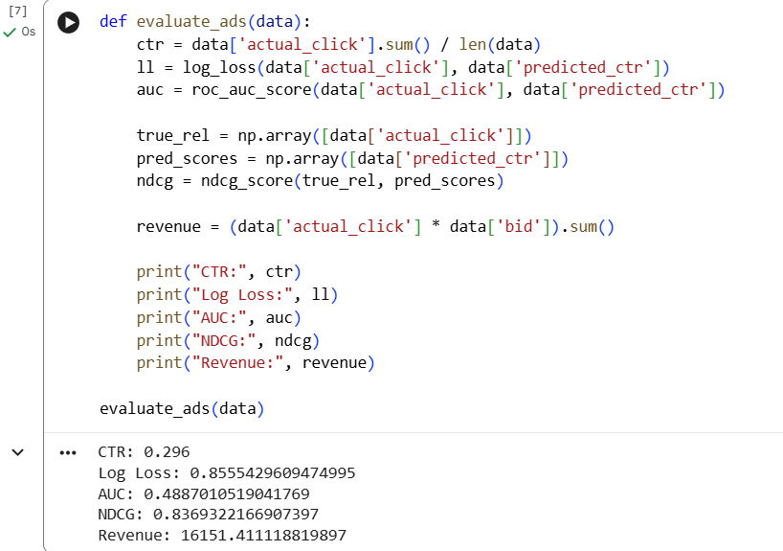

Practical 9 - Design a personalized Newsfeed
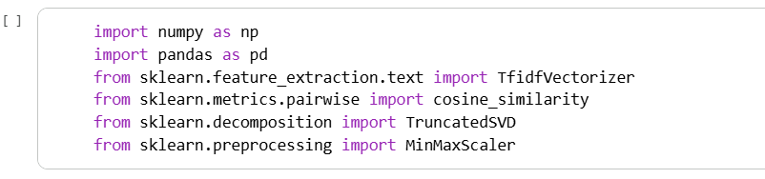
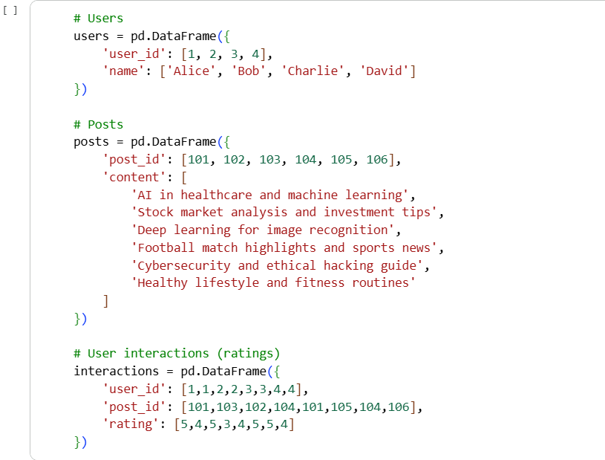
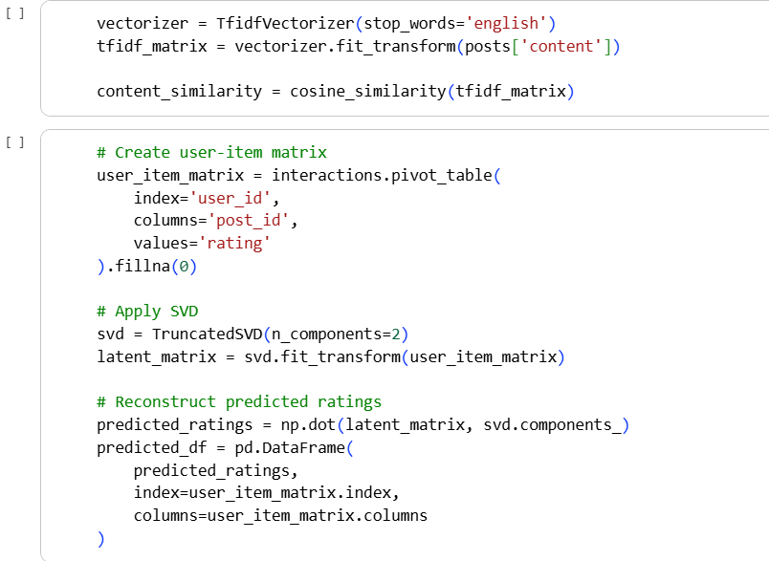


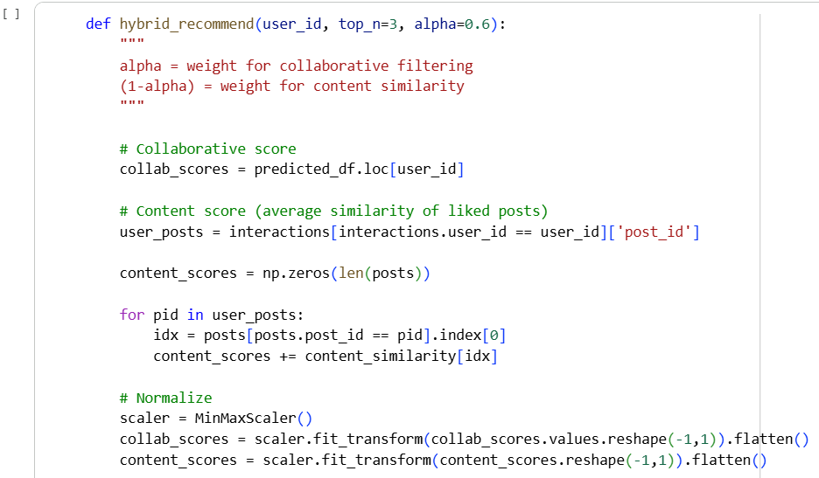
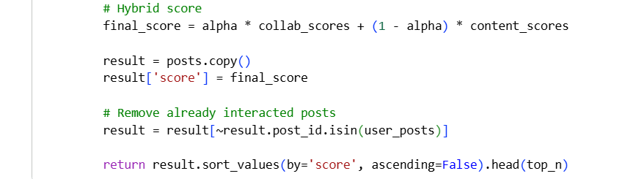
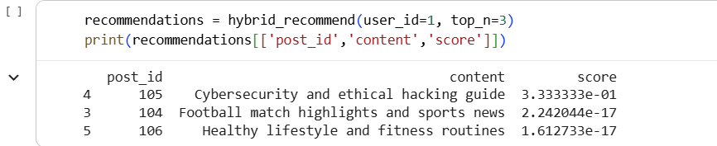
Practical 10 - Design a Image Classifier
